UMKC CS5542

**Team 3**

**Zeshan Ather, John Goza, Hongkun Jin, Mouqing Jin**

**Increment 1 Report and Software Overview**

**Project objectives**

The project presented by our team is to be an intelligent, multi factor score prediction software specifically targeted for basketball. This project contributes to the current state of research by leveraging both shallow and deep learning techniques on video data to create a time based linear score prediction, as well as demonstrating the effectiveness of multi factor prediction with software modeling. By leveraging competing software models against each other we believe we can significantly enhance correct software prediction of the desired output, the score of the basketball game.

**Features:**

The following can be use case scenario in our project

* Score prediction tracked over time
* Winning prediction over time
* Percentage of the score over the time
* Fouls rate prediction

**Approach**

This project will attempt a threefold approach to accurately model the score of any provided basketball footage. First, a TensorFlow deep learning model will be trained on a dataset with prominent scoreboard and scoring play footage to create an untrained model. Secondly, all footage will be compared to supervised, trained models created in Spark. Spark models will focus on shot types, scoreboard processing, and distinct motion for different scoring models.

**Data Sources:**

Our data sources are a collection of public domain videos featuring common basketball shots from a wide variety of different angles. These videos are manually categorized into three categories: three point shots, free throws, and two point shots, with two point shots including a diverse sample of dunks, layups, and individual shots. Videos were accessed primarily from YouTube, and are currently a mixed arrangement of individual shots and shot-type “compilation” videos (e.g. “All three point shots from the NBA All Star game”). Moving forward, data will be edited to turn compilation videos into a series of smaller videos more focused on individual shots. YouTube 8M may also be used later in the project, as it contains a wide variety of basketball shots (research.google.com/youtube8m). If samples are required for the Scoreboard natural language processing portion of the project, video will be sourced accordingly.

**Expected Input/Output:**

Our Input will be the user specified long basketball video. We will separate the frames from our videos. We will train our image classification models with the extracted frames. Then find the main frames on the basis different actions and modeled shot profiles. Our output will be a summarized video with the different shots attempted in the match matched to the calculated expected match score.

**Algorithms:**

Primary algorithms under consideration for Spark models include:

* Decision Tree
* Random Forest
* Natural language processing (NLP)

There are many NLP libraries available to be implemented in Spark. The primary focus for library selection will be numerical processing ability. For our basketball shot models, both Decision Tree and Random forest algorithms fit well, as a given basketball shot has a number of quasi-binary motions to decide upon.

**Related Work:**

Relevant paper/work we found

* This paper on deep learning-based basketball video analysis helped us a lot in giving the basic idea of the project and different techniques to accomplish the task of video analysis

<https://link.springer.com/content/pdf/10.1007%2Fs11042-017-5002-5.pdf>

* The Kinetics Human Action Video dataset by Joao Carreira

<https://arxiv.org/abs/1705.06950>

* A potential NLP candidate for our project

<https://github.com/scalanlp>

**Project Management and Plan:**

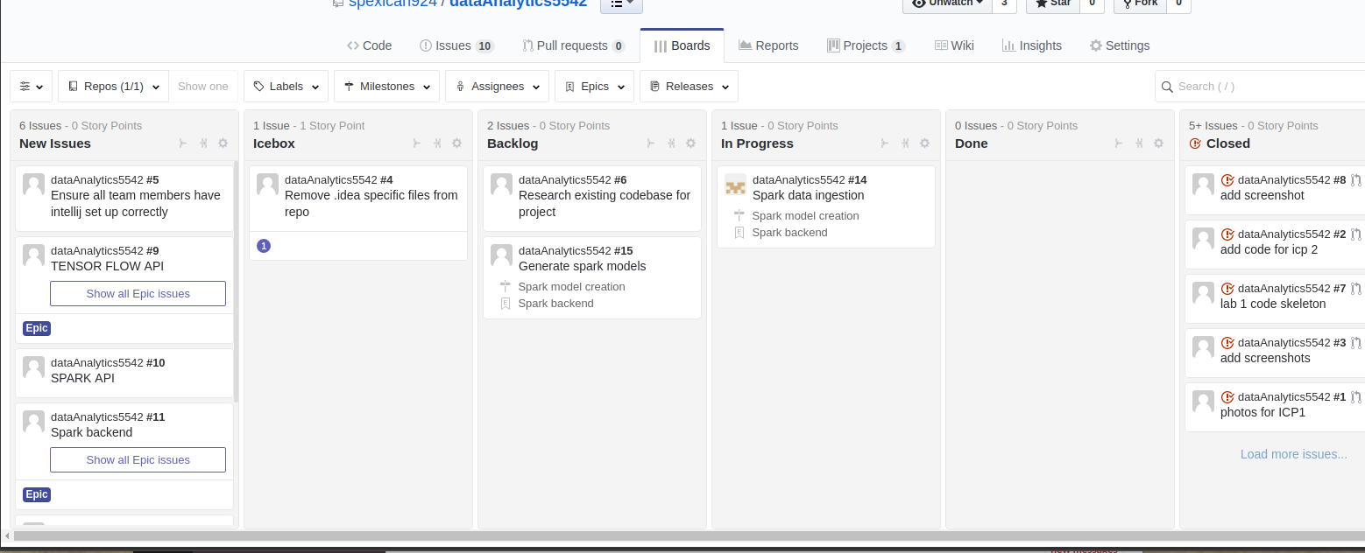

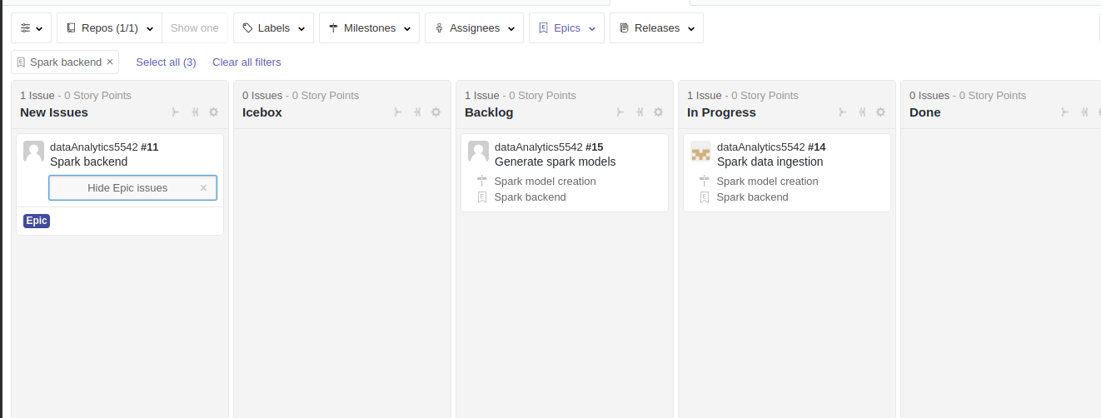

**Work Completed:**

We have download the dataset of almost 4,5 actions/classes. We have build 2 classification models: random forest and naïve Bayes. We have successfully separated the frame from the videos and extracted the main frames from the set of already extracted frames. We have successfully predicted images on the web server by configuring the Akka services.

**Task division:**

Jack worked on random forest model building and training of the model with frames extracted from the data. Finding the related work and searching related models. Serves as de-facto project manager, currently working on combining existing tasks into a cohesive package for simple model generation/refactoring.

Zeshan worked Naïve Bayes building and training model. Finding the related work and searching related models. Current working status, Deep learning with TensorFlow API implementation

Jin Hongkun working on Data Collection and documentation. Training the models with more data collected. Finding the related work and searching related models.

Jin Mouqing working on Data Collection and documentation. Training the models with more data collected. Finding the related work and searching related models

**Work to be Completed:**

We have following thing in our to do list

* Create an android app
* TensorFlow API connection/implementation of tensorflow model
* Spark web endpoint setup
* Collecting more data for better training of the model
* NLP for spark numerical scoreboard processing
* Summation of predicted scores